Sprint Review: S#1

Sprint 1

Date: 2/5/2021

Scrum Master: Katelyn Knight (s3839920)

Development Team: Gayan Wijesuriya (s3843584), Trong Khoa Dang(s3846329), Hoang Tran( s3720825), Zhengchao Sun(s3737536), Huiyu Wang(s3737937)

# Sprint Goals

In this sprint we aimed to create and code 4 features into our website. Those 4 features included:

* The ability to register an account and inputting the account into a database
* Login and logout of accounts
* Creating and displaying a database of movies on our site
* A search function that could sift through the movies database.

Surrounding these 4 features, we also planned to develop the UX of the site, a consistent design that would be present on all our pages and functions. All these goals were aimed to be completed by 2/5/2021

# Status Overview

The planned sprint items were met/ finished according to the planned deadline and all have been tested with all known defects/issues resolved. All 4 features we aimed to create are currently functioning with a consistent UX design across all 4 features. Although functioning, there’s always room for improvement and our 4 features could be improved which shall be discussed below.

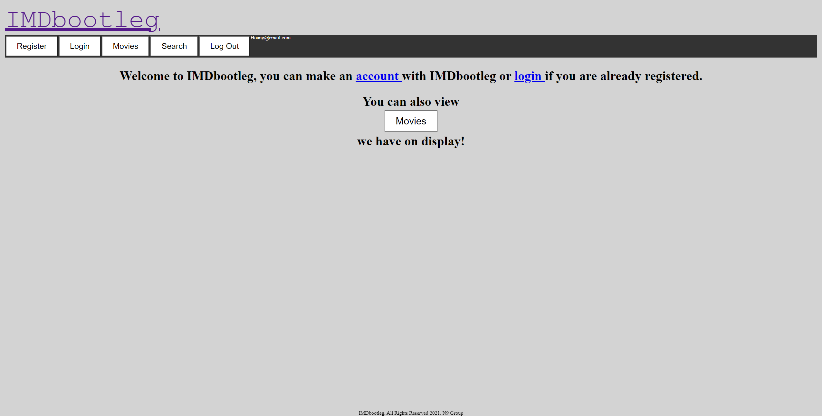

Figure 1- Homepage

Figure 1 shows the home page. On it, the page displays the websites title, a navigation bar with links to the 4 features of the sprint goal that have been met and completed. Beneath the navigation bar is also a greeting page and a footer.

The homepage is currently rather barebones and could be improved on. The home page could display more information and have a fuller more completed design. In the future, we can add more content into the home page, perhaps movies or information we would like to showcase, giving it an overall fuller feel.

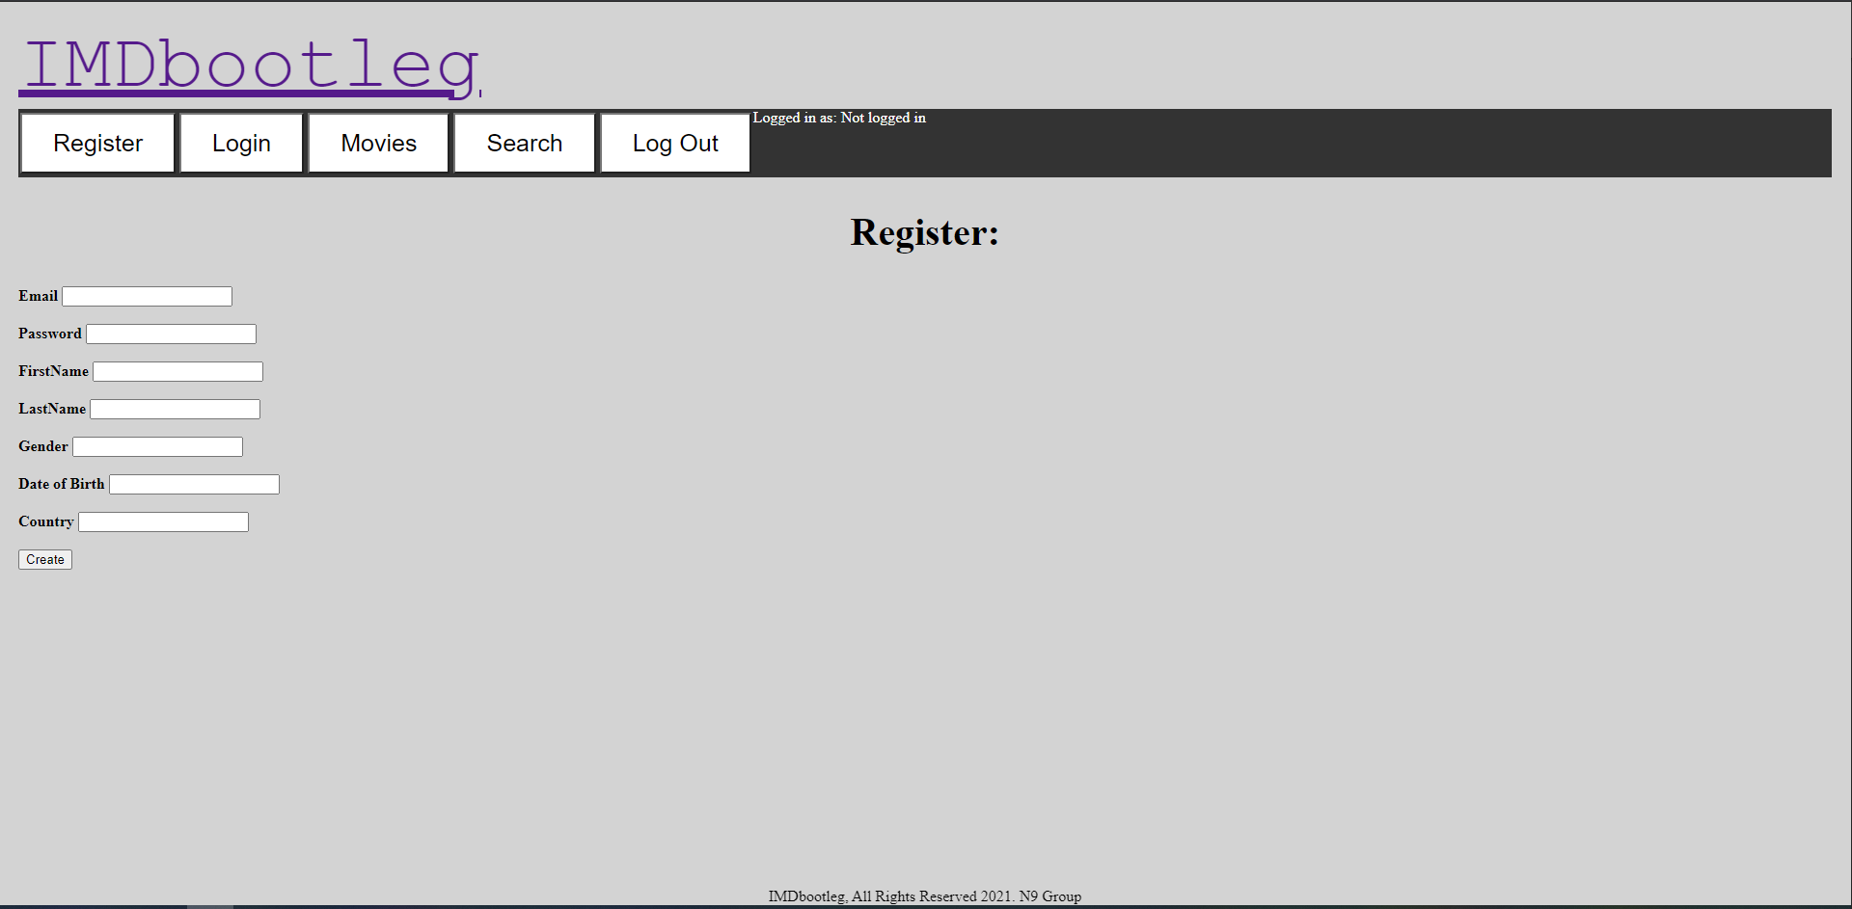

Figure 2- Register account page

In figure 2, users can access this page if they click “register” on the navigation bar, or the “account” hyperlink in figure 1. Figure 2’s page allows users to register an account with the website.

This page/feature functions exactly as we planned in our goals. It takes the users information and inserts it into a database which can later be used to login (Figure 3) For future goals, the UX design could be improved on as the text input fields are not aligned, but otherwise the feature is fully functional.

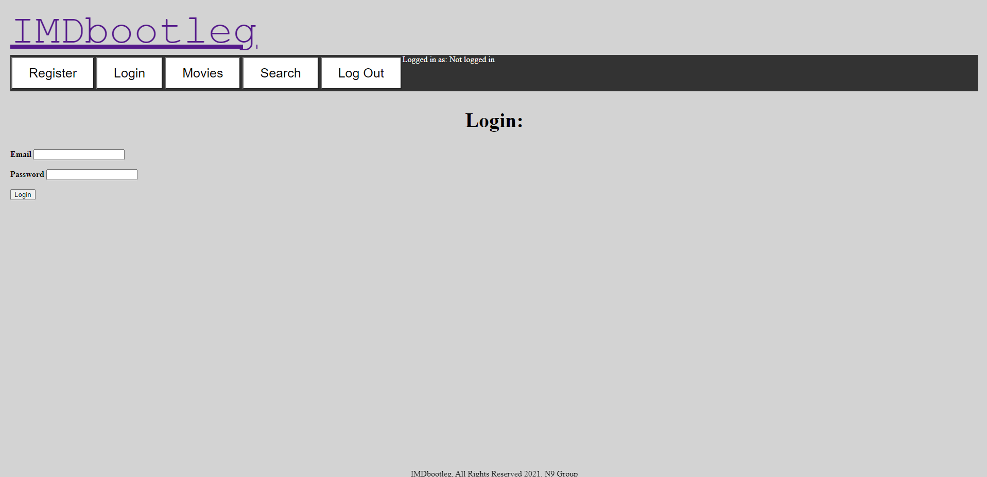

Figure 3- Login

In figure 3, users can click on the ‘login’ button on the navigation bar, or, if they are on the home page (Figure 1), they can also click on the blue ‘login’ hyperlink in the greeting message.

Functionally, Users can login to the website, however the logout button is displayed even if users are not logged in already. For future goals, this button should only be accessible once users are logged in.

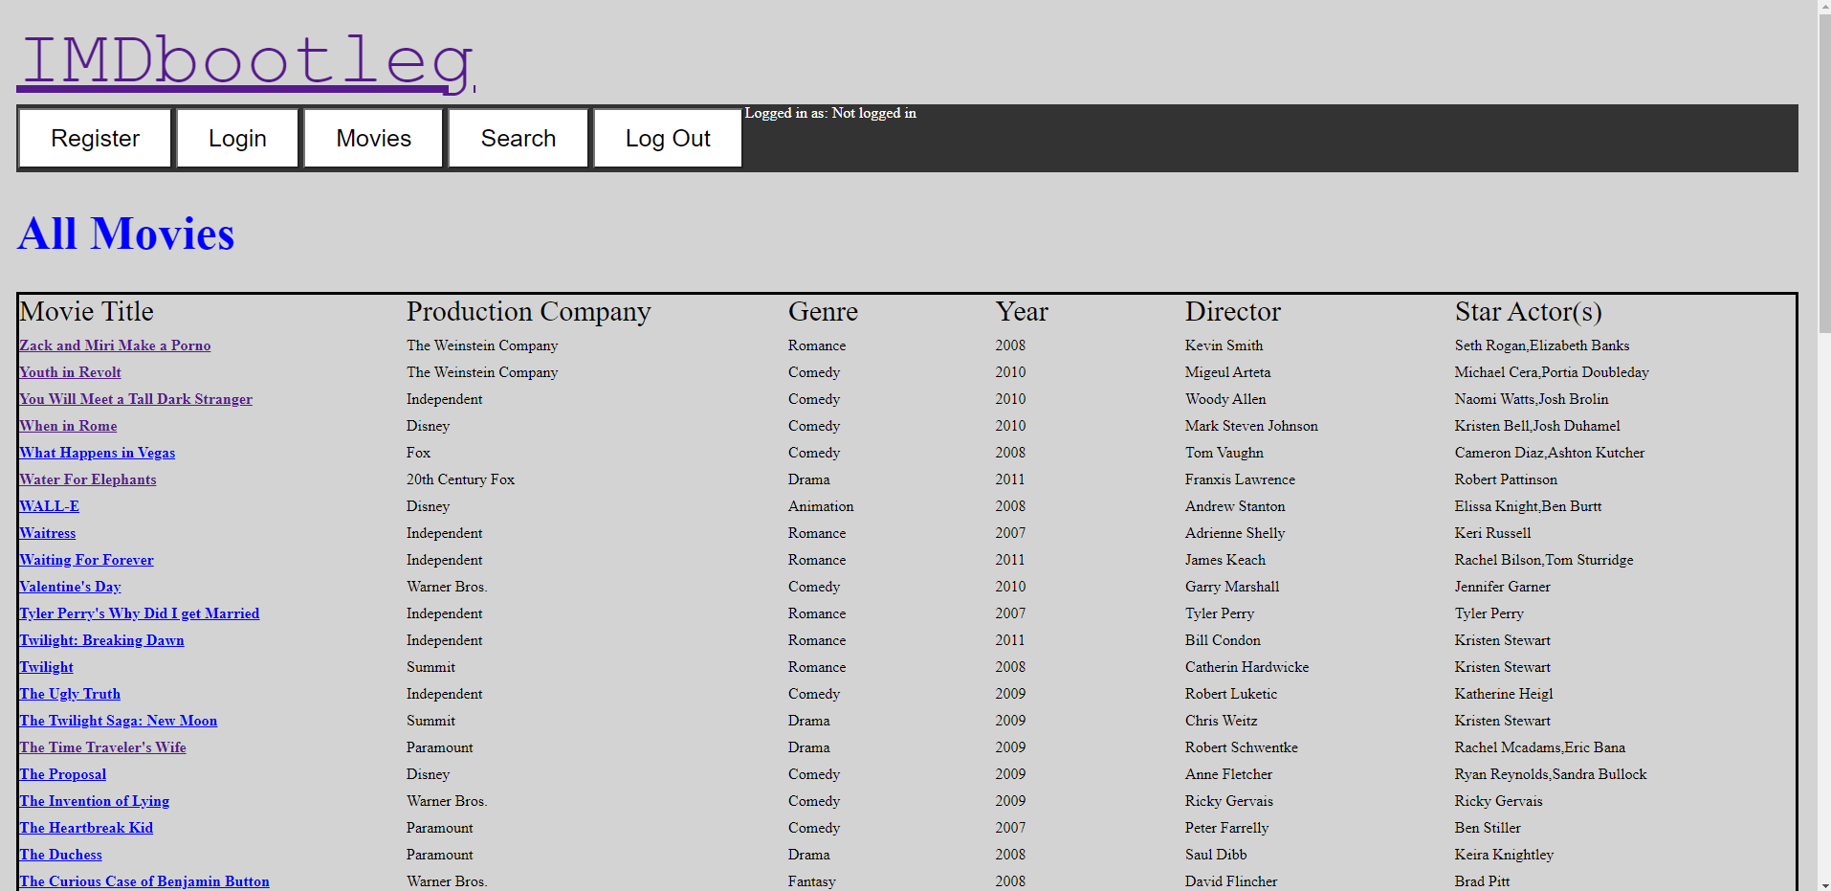

Figure 4A- Displaying Movies from the Database

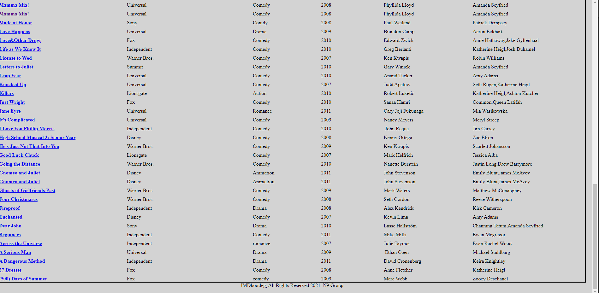

Figure 4B- Display Movies from the Database, continued

This page (Figure 4) displays the information from out database. The information outlines particular movies, the production company that produced the movies, the movies genre, the year the movie was made, the director of the movie and the star actor(s) of the movie. The list extends and continues down to the bottom of the page where the footer is placed (Figure 4B)

This feature functions well, it displays the information from the database in a neat and consistent matter for all movies.

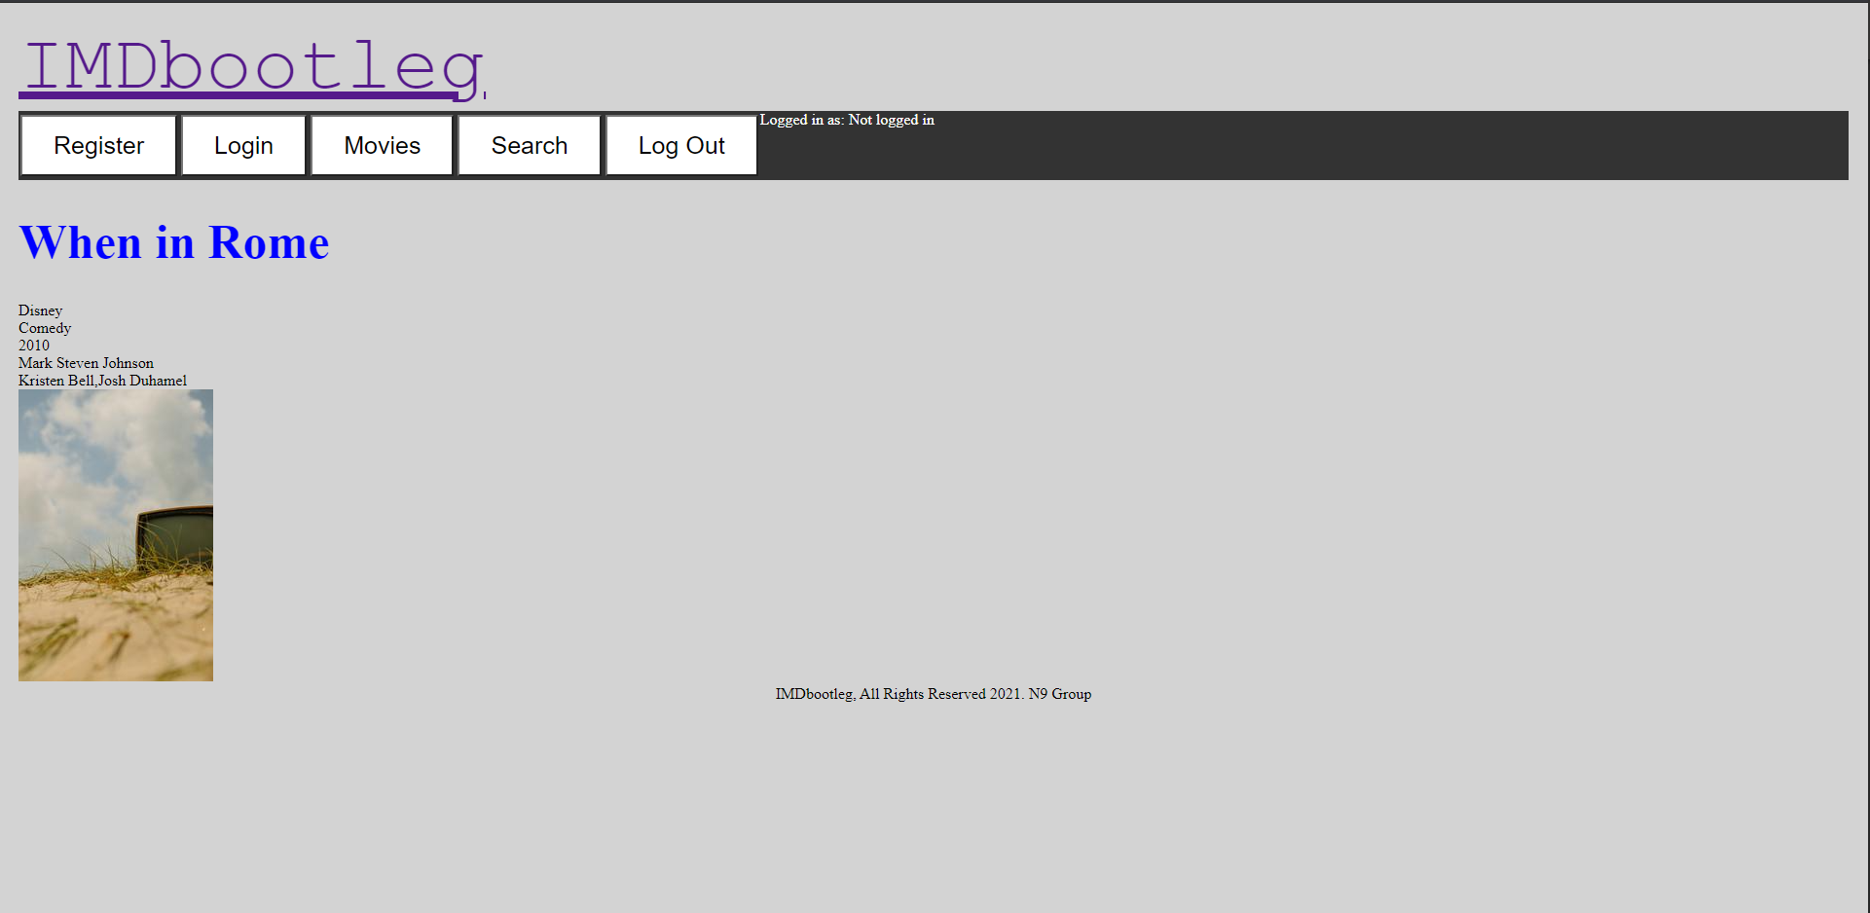

Figure 4C- Display Movies from the Database, Continued (specific movies)

In Figure 4C, the page isolates one movie and its relevant information (title, production company, genre, year made, director and star actor(s)). Users can access specific movies by clicking on their title names (the blue hyperlink) in figures 4A and 4B.

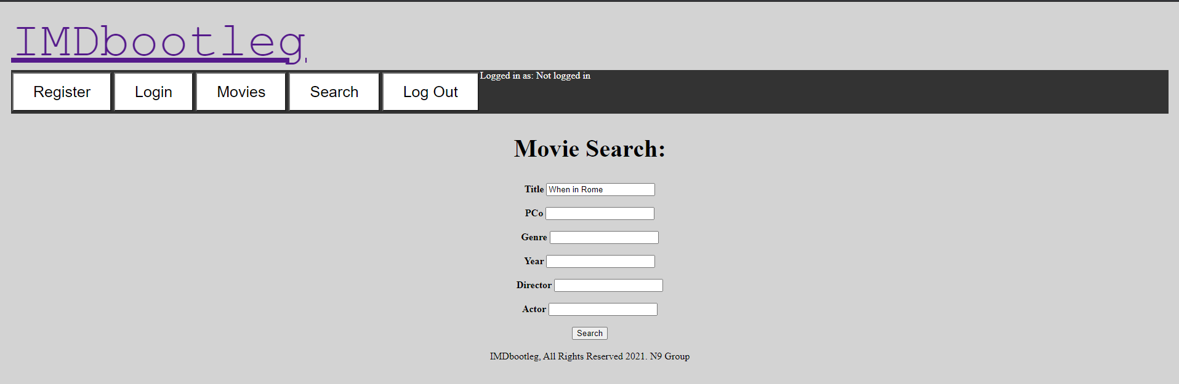

Figure 5A- Search function

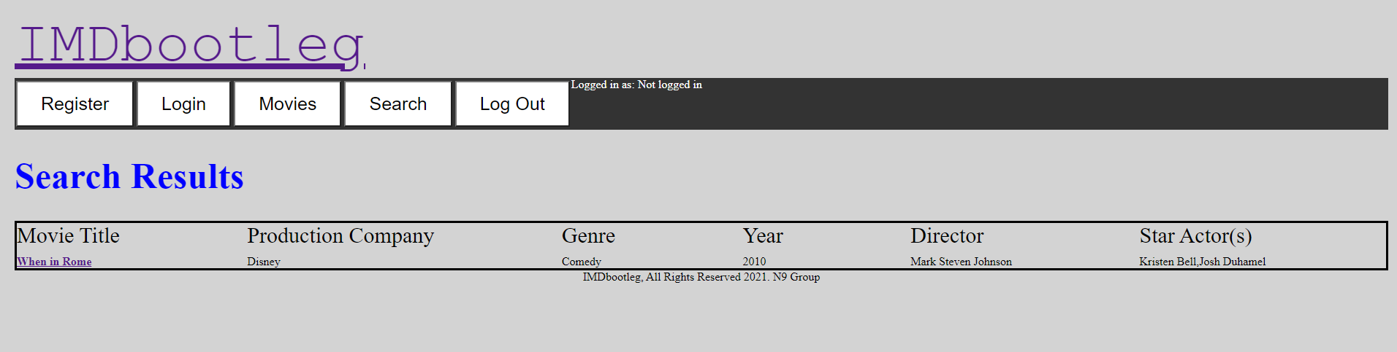

Figure 5B- Search function, displaying results

In Figure 5, Users can input search fields into any of the text inputs to search for movies that match their inputs. Users can search via the movies title, Production companies, genres, year of production, directors, or actors. Once users have inputted their search fields, they can select the search button and the results will be outputted (Figure 5B)

Currently, the search function only works if users input all the information they are searching into the text fields. For example, if users wish to look up the movie “When in Rome”, they will have to input the full name into the search function. If users inputted “Rome” into the search function, the movie “When in Rome” would not display. For future goals, this should be fixed and keywords should be used to search through the movies database, rather than entire names.

# Sprint Statistics

Figure 6A- Burndown chart for sprint session 1

For Sprint Session 1, we started off slow, being held back by other commitments, we did not actually start the development until day 8. Although we were very behind for most of the day’s goals, we actually ended up completing the coding for all 4 features before the due date.

Figure 6B- Sprint burndown

Overall, we are exactly where we need to be. The goals we set out to complete are completed and we have created 4 features as per the goal.